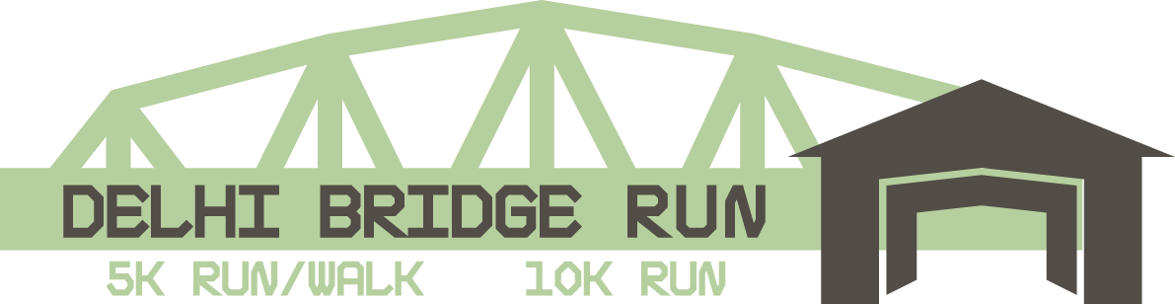

Dear Friend,

I am writing to ask for your support for the 25th Annual Delhi Bridge Run. The Delhi Bridge Run has become an annual affair that attracts over 600 race participants plus over 1,200 spectators from Delaware County, the Southern Tier, Catskill Mountains, Capital District, Metro- NY/NJ, and beyond. The Annual event consists of a 5K Health Walk, 5K and 10K Run.

The Delhi Bridge Run, hosted by The Catskill Ladies Association to Support and Inspire (C.L.A.S.I.) takes place annually the first Saturday in June, this year on, June 6, 2020. Proceeds from the event benefit; Scholarships to two graduating Delaware County Seniors and a charity or school club of their choice.

Please show your support for our local youth and community at large by sponsoring this year’s Delhi Bridge Run. This year’s event promises to continue the momentum without missing a beat. The planning committee has already begun to plan and organize, and all group members are dedicated to making the event a success. Please know that we count on the commitment and hard work of our group members and enthusiastic volunteers, as well as outside financial support from our sponsors. While it is difficult to determine what an appropriate request is, we hope you will consider joining us at one of the following levels:

$50 Company Name on Signage at Registration Table
$100 Company Name on T-Shirt
$250 Company Name in Bold on T-Shirt
$500 Company Logo and Name on T-Shirt
$1,000 Company Logo on T-Shirt and Runner’s Bib

All sponsors will be listed on signage at Registration Table. To be listed on the Bridge Run registration site email us your logo at clasiorg@gmail.com.

This year we will continue to give all sponsors $100 and over one free race registration. To redeem this registration please return the enclosed pink registration form with your donation no later than May 1st.

Please make your sponsorship payment payable to: C.L.A.S.I. and mail to C.L.A.S.I. PO Box 252, Delhi, NY 13753. Or search Lisa Henderson@CLASI-LADIES and Venmo us your electronic payment. Please have payment in as soon as possible. To ensure proper recognition we need your payment no later than May 1, 2019. For information about Scholarship Opportunities for Delaware County graduating seniors or to register as a participant visit C.L.A.S.I online at www.clasiladies.com.

Call Amy Beveridge at 607-437-6671 or Lisa Henderson at 607-746-6942 or send us an email @ clasiorg@gmail.com with any questions.

Thank you for your sponsorship of the Delhi Covered Bridge Run.

Sincerely,

25th Annual Race Committee; Amy Beveridge- East Meredith, Lisa Henderson-Meredith, Krista Finkle-Andes, Liz Frisbee-Delhi, Heather Hilson-Delhi, Raegan Reed-Delhi, Sarah Poole-Delhi, Brittany Mondore-Delhi, Kim Eighmey-Delhi, Christina Viafore-Delhi, and Sarah Kellogg-Walton
Catskill Ladies Association to Support and Inspire (C.L.A.S.I) www.clasiladies.com.
Email us @ clasiorg@gmail.com

